Product Design

|  |  |
| --- | --- |
| **Team** | **Team-3**  Karan Nijhawan  Sanchit Jalan  Sreeja Palle  Manda Vaishnavi Reddy |

# Design Model

|  |  |
| --- | --- |
| User | Class state   * Maintains user information such as username, password, and user preferences.   Class behavior   * logging in * logging out * updating user information * managing user preferences. |
| Image | Class state   * *Information about the image file, such as file name, size, and format.* * *Metadata related to the image, such as creation date, uploader, etc.* * *Navigation controls state (e.g., current view angle, zoom level).*   Class behavior   * *Methods to import/upload image files.* * *Functionality to navigate the image using controls provided.* * *Functionality to save annotation data.* * *Export methods to save the annotated image with labels.* |
| Annotation | Class state   * *Metadata related to annotations (e.g., creation date, author).* * *Position and size information for the annotated regions.*   Class behavior   * *Methods to create, edit, and delete annotations.* * *Methods to retrieve annotation data associated with an image.* |
| Label | Class state   * *Labels or tags assigned to a project for categorization or classification purposes.* * *Metadata related to labels (e.g., creation date, color-coding).*   Class behavior   * *Methods to assign, remove, and modify labels.* * *Add Color for each label.* * *Methods to retrieve images or annotations based on specific labels.* |
| Project | Class state   * Project details such as name, description, and associated images.   Class behavior   * *Functionality to display uploaded images and navigate between them.* * *Interface methods to interact with user inputs and controls.* * *Sort and Filter options* |
| Dashboard | Class state   * Contains Project list and other navigations   Class behavior   * *Create Project option* * *Acts as an interface for other functionalities* |

.

**UML Class Diagram**

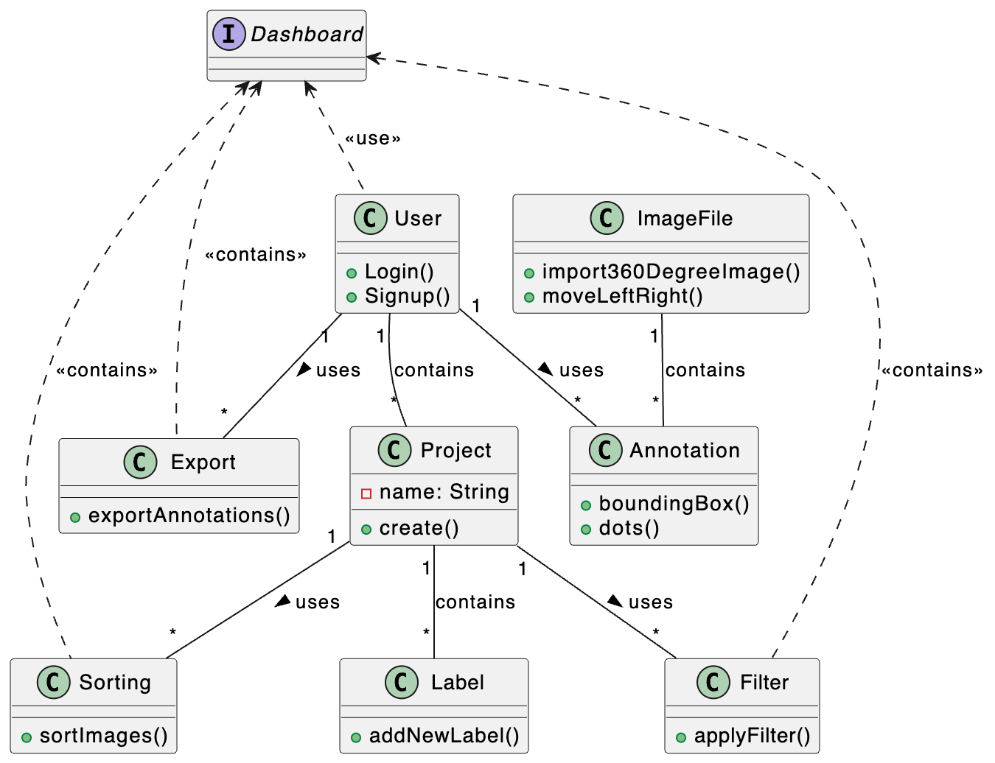

# Sequence Diagram(s)

# 1.

# 

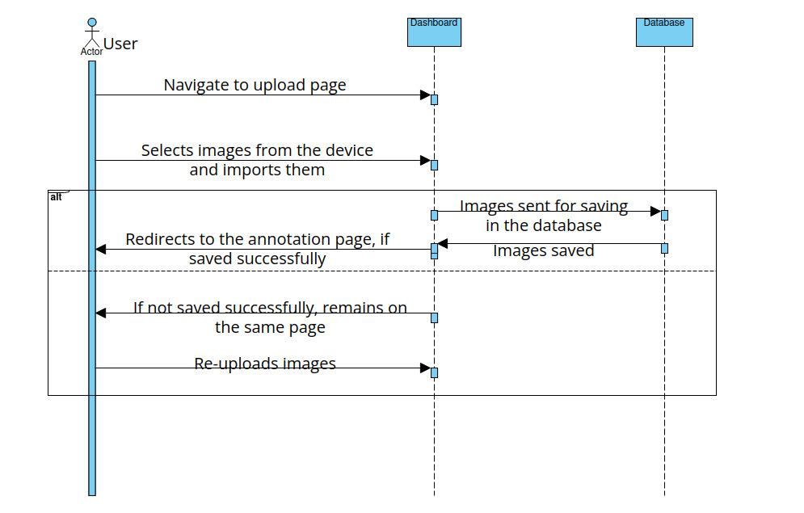2.

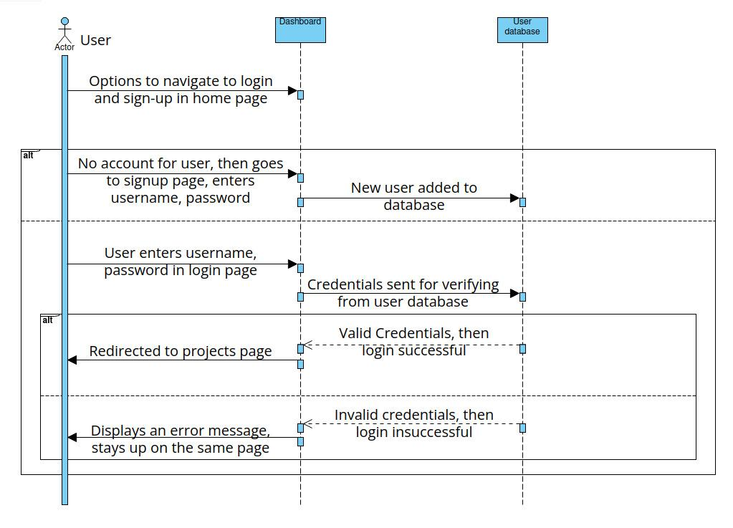

3.

4.

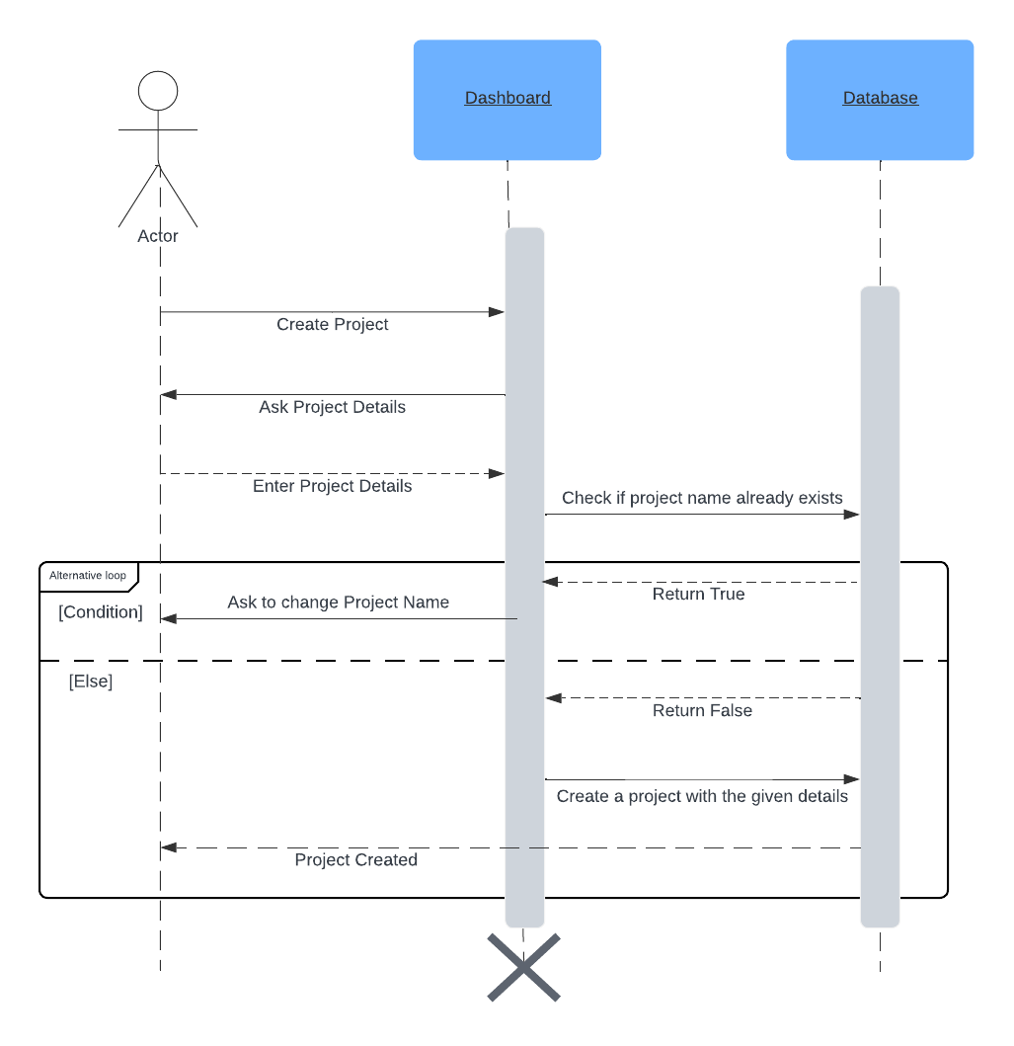

Database Design

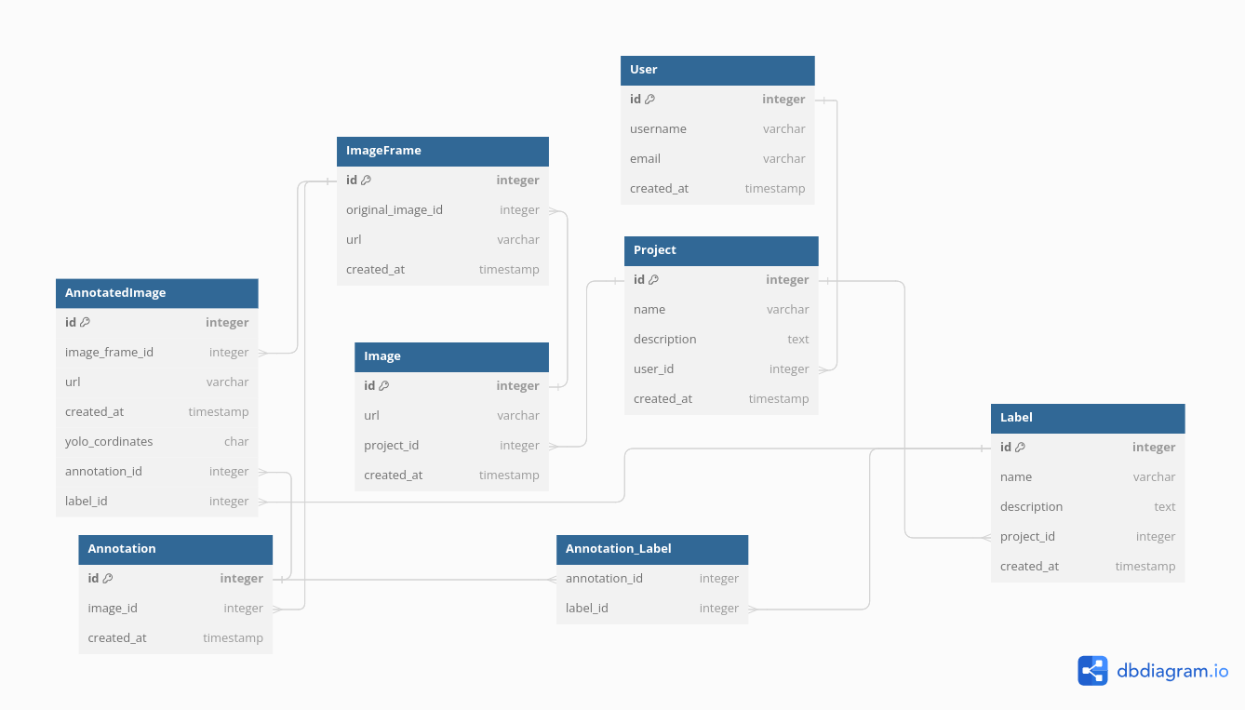

**Design Rationale**

The redesign of the database was driven by the need to resolve inherent conflicts within its previous implementation, which were impeding its functionality. To address this, a deliberate decision was made to integrate annotations ,labels into the database model. This design choice was motivated by the desire to improve the system's operational efficiency by enabling more accurate and structured data categorization.

Furthermore, the redesign of the user interface (UI) was undertaken to align with modern design principles and enhance user experience. By revamping the UI, the aim was to create a more intuitive and user-friendly interface that facilitates seamless navigation and interaction with the database. This design rationale ensures that the updated database not only resolves technical issues but also prioritizes usability and accessibility for users.

In the redesign process, special attention was given to customizing various URLs to ensure a smooth experience with GET and POST requests, facilitating effective communication between the frontend and backend systems.